**Department of Computer Science and Engineering**



Report on Mini Project

FileSpark

#### Course Code : 20CSE41 Course Name : Web Programming

##### Semester:V SEM Section: A

**Submitted To:**

## Ms. Shruthi M

## Assistant Professor

## Department of

## Computer Science and Engineering

**Submitted By:**

Avaneesh Shambhat (4NM20CS044)

A Mouniyaa (4NM20CS001)

**Date of submission:**

9/12/2022

#### Signature of Course Instructor

# ABSTRACT

**560,000** new pieces of malware are detected every day. There are more than 1 billion malware programs available to public. Every minute, four companies fall victim to ransomware attacks. Trojans account for 58% of all computer malware. Hence Cybersecurity is important because it protects all categories of data from theft and damage. This includes sensitive data, personally identifiable Information, protected health information, personal information, intellectual property, data, and governmental and industry information systems. Cyber threats can come from any level of your organization. Workplaces must include cybersecurity  awareness training to educate staff about common cyber threats like social engineering scams, phishing,  ransomware attacks, and other malware designed to steal intellectual property or personal data. Our website shows live demonstration on malware attacks.

This website uses Hypertext Markup Language (HTML), Cascading Style Sheets (CSS), NodeJS, ExpressJS, EJS and Database Management System (DBMS). Using HTML and CSS we have structured and designed the contents of the webpages along with help of BOOTSTRAP. To manage the user information  we made use of MySQL.

# TABLE OF CONTENTS

Title Page i

Abstract ii

Table of Contents iii

Introduction 4

Problem Statement 5

Objectives 5

Hardware/Software Requirement 6

Methodology 7

Implementation Details Results 8

Conclusion and Future Scope 15

References 16

# INTRODUCTION

# 

This is a website from where u can download the apps needed for your system may be for Windows, MacOS, Linux, Android. All the apps available here have additional features than the apps available elsewhere hence attracting people to download it. We have included top downloaded and high rating apps.

Our website is mainly based on the concept how third party website (malware website) works like. This is a website enables curious individuals or students who are interested in understanding the attacks field. Helps them to do their research and acts as a base element. We have a live and a working demo on what exactly happens. I believe not all website should be about interacting with users some need to be informative and spread awareness for future good.

# PROBLEM STATEMENT

It is an App Store from where people can download various apps needed by user. It is a common tendency for an individual maybe a student or anyone else to give up or leave in between a project or a project due to lack of resources. This website helps people to gather information and experience live demo.

# OBJECTIVES

* Spreading awareness to people about the malware website which are plenty in internet now a days.
* Downloading apps for various operating system.
* Making oneself information Enrich.
* Helps finish paperwork or projects.

**HARDWARE / SOFTWARE Requirements**

Software

* Operating System: Windows, Linux
* Database: MySql
* UI Design: HTML, CSS, Bootstrap
* Server Side: ExpressJS, EJS(embedded  Js)
* Web Browser: Google Chrome, Mozilla Firefox, Brave
* Software: XAMPP, Visual Studio Code, Metasploit

Hardware

On attacker’s side

* Laptop with Kali Linux installed with minimum 8gb RAM and 100gb storage space.

On victim’s side

* Laptop with Windows 10 installed.
* Laptop with MAC OS installed which has Intel processor.
* Laptop with Debian Linux installed.
* Android smartphone with Android version 10 or below.

# 

# METHODOLOGY

# Our website works in the following way:

# Initially there is login page where we have to enter email and password if the entered credentials are correct then the page is directed Homepage in which we can choose their operating system. There are total of 4 operating system downloads available in this website ie. Windows, MacOS, Linux, Android.

# Every User can download the software, each software has its software name, version, rating, age group, reviews, date stored in the database. From which all the info is retrieved for all

# 

**IMPLEMENTATION,** **RESULTS AND DISCUSSIONS**

* Sign up page - A new user can create an account and only then he can login.

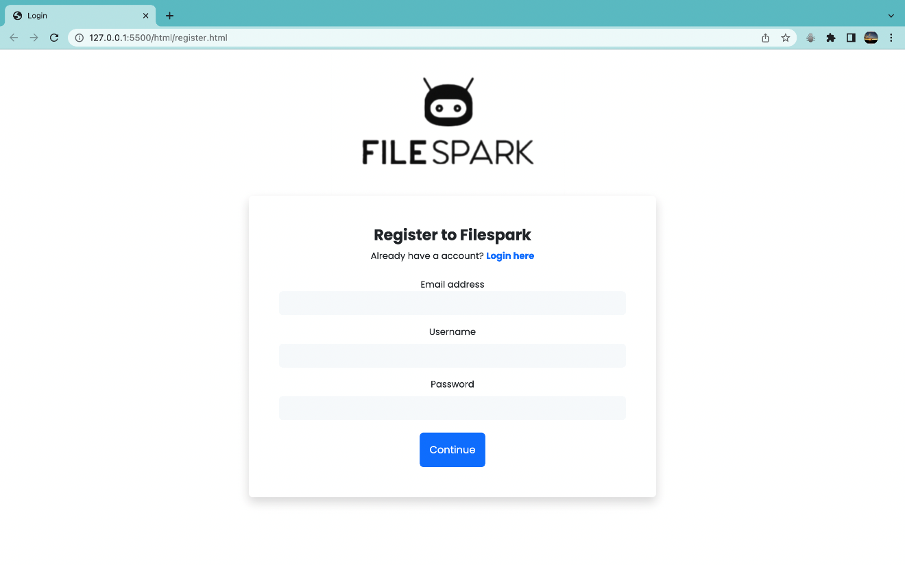

* Login page - A user has to login to the website to visit the page or to download any software.

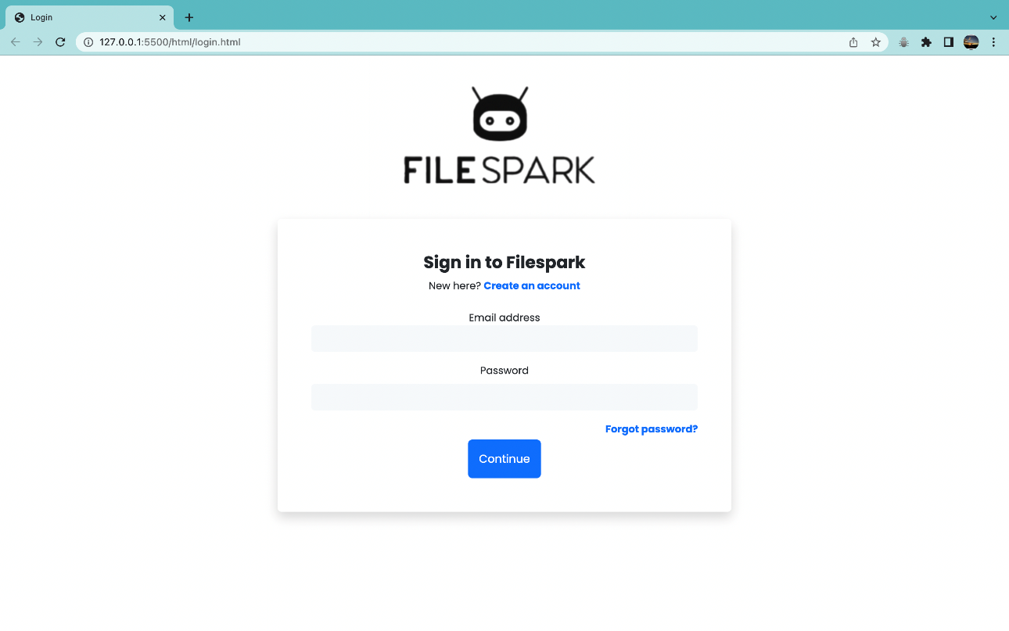

* Reset password page – If a user forgets his password he can enter his details to reset the password.

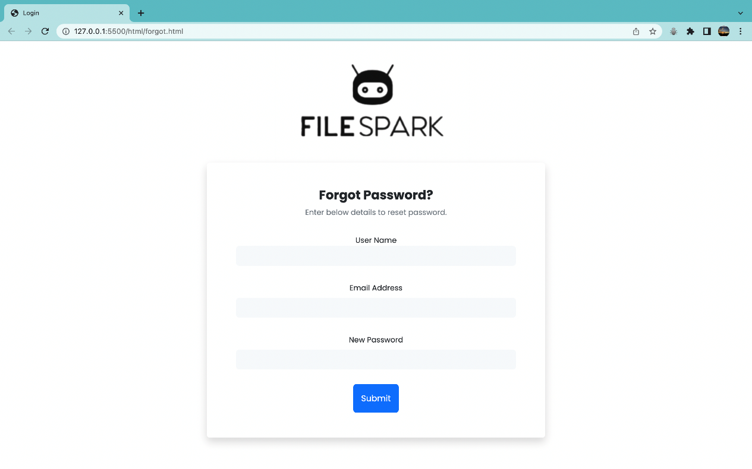

* Home page - View of the website from where we can choose the operating system accordingly

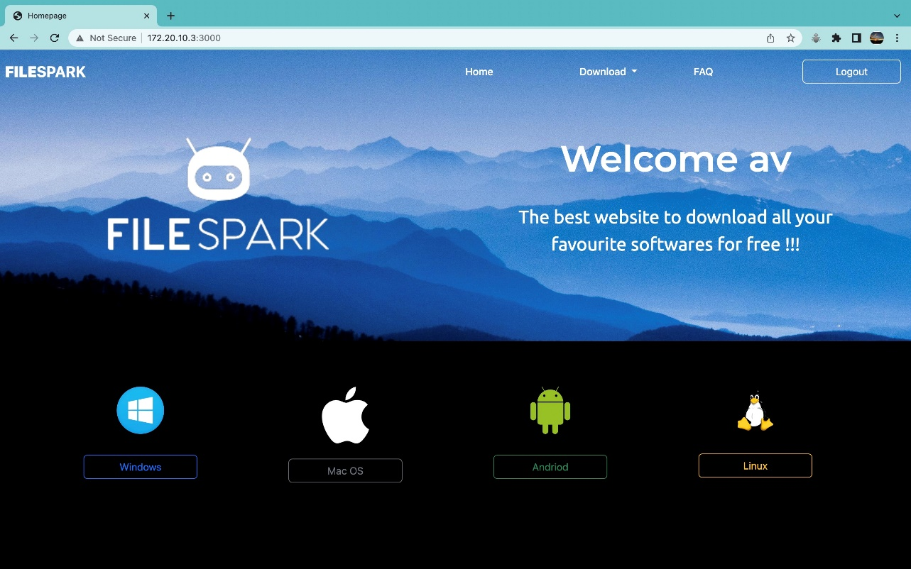

* Top downloads - A carousel representing the top downloads in our website

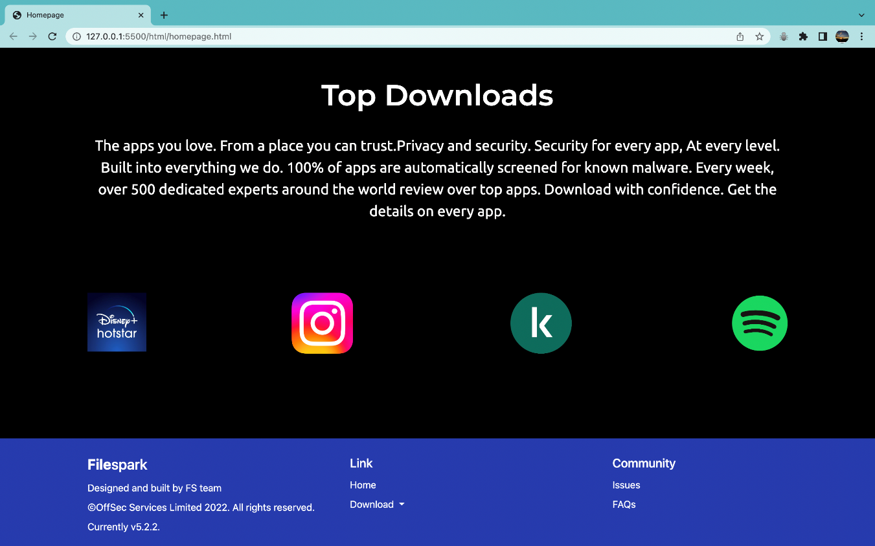

* Windows downloads - A page with all the apps available for windows download

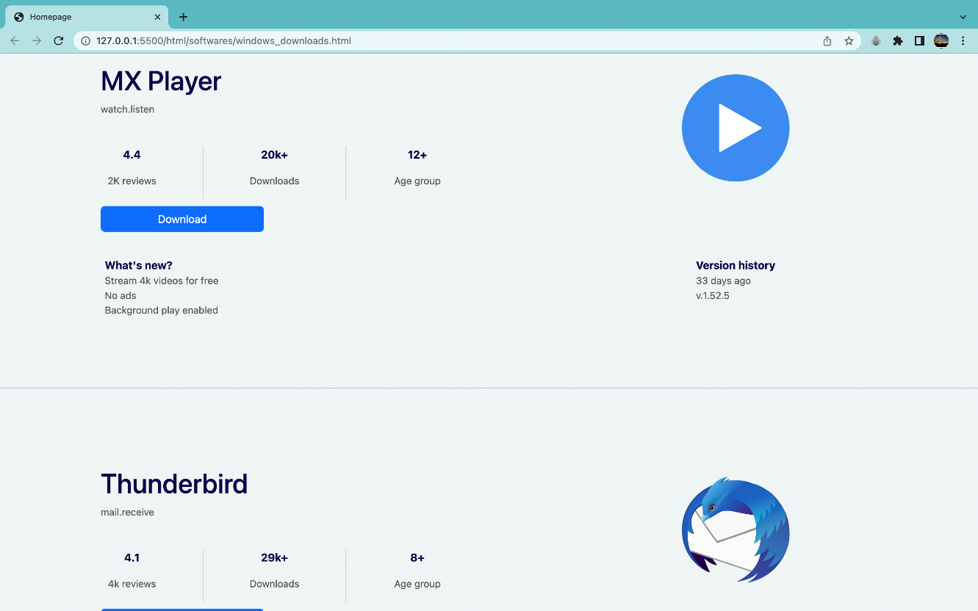

* MacOS downloads - A page with all the apps available for MacOS download

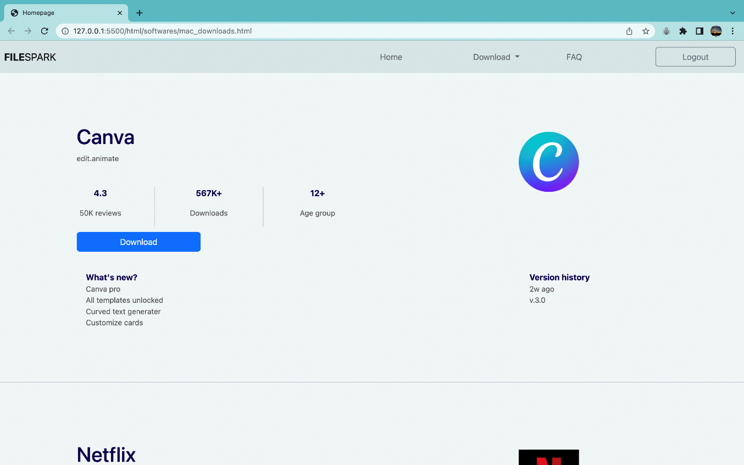

* Android downloads - A page with all the apps available for Android download

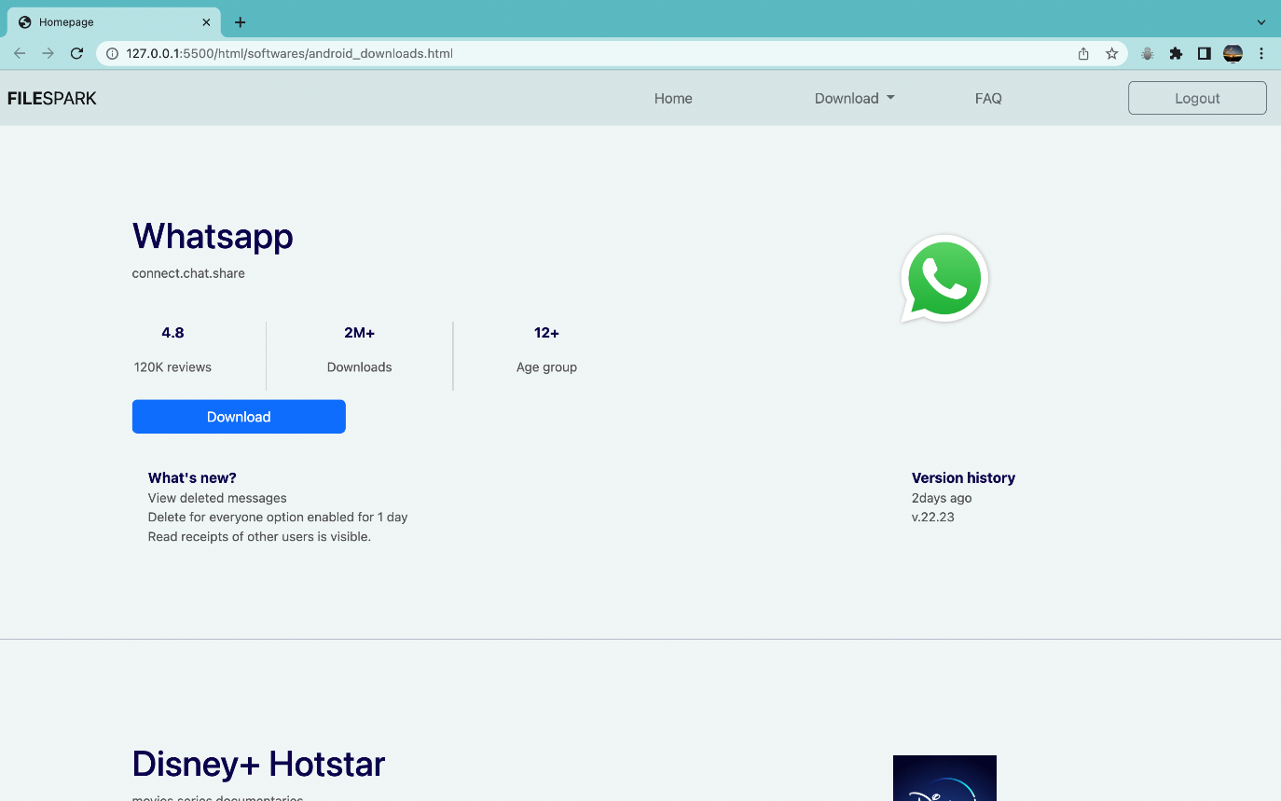

* Linux downloads - A page with all the apps available for Linux download+

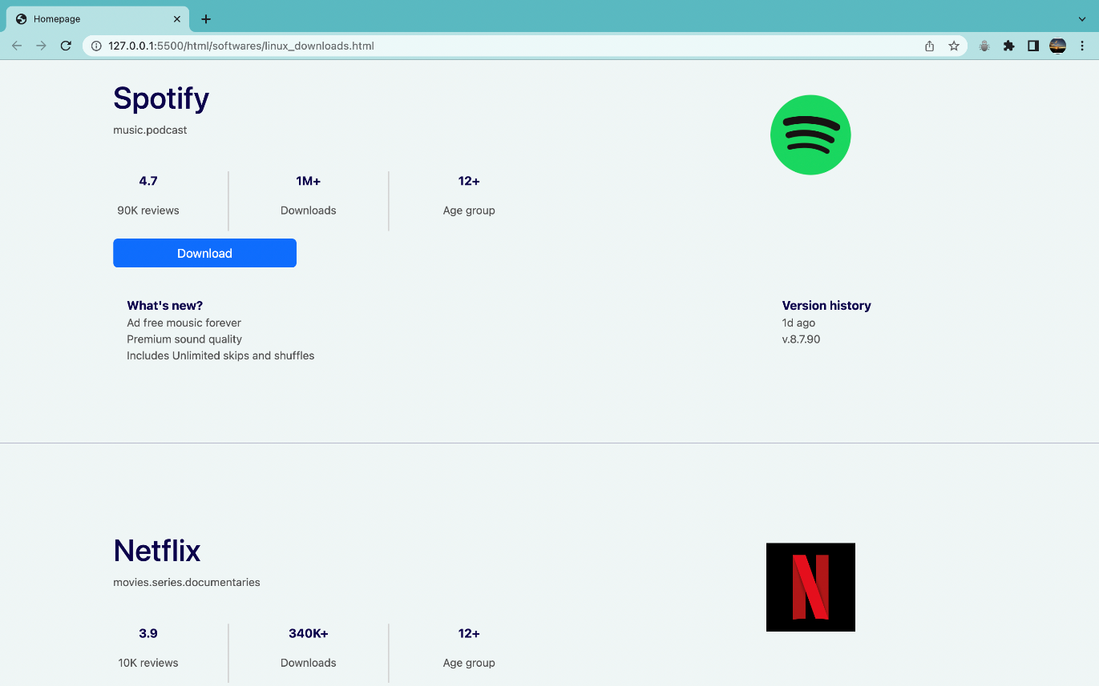

* FAQ - A page with cards and dropdown containing frequently asked question.

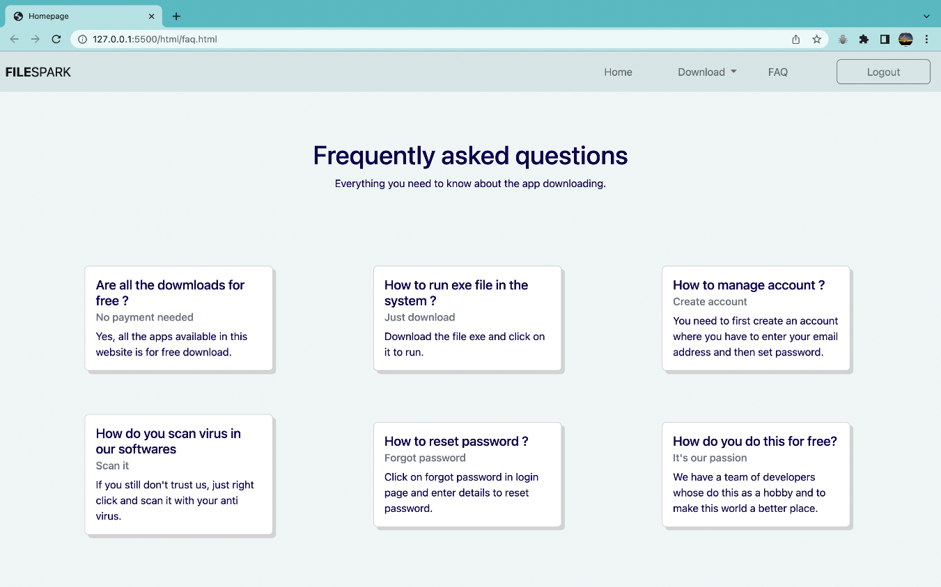

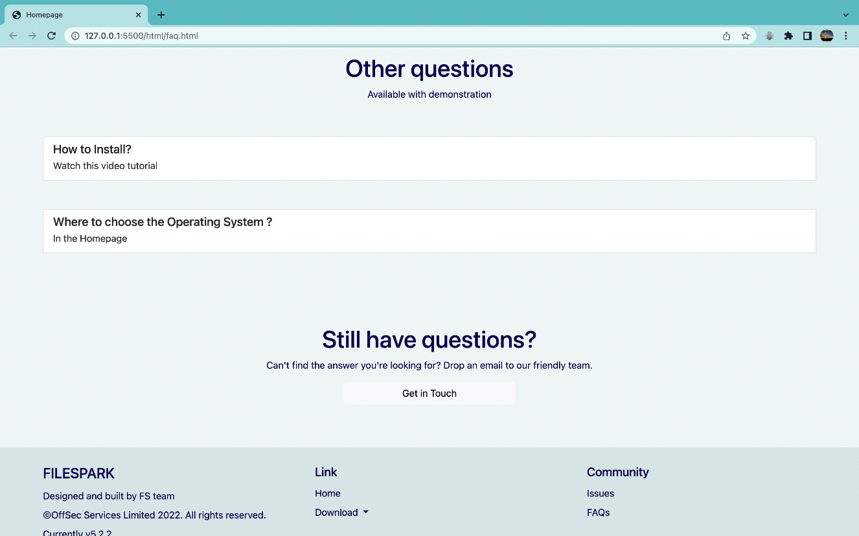

* Demonstration

Create a payload using Metasploit with the following command.

Use msfconsole to setup a listener.

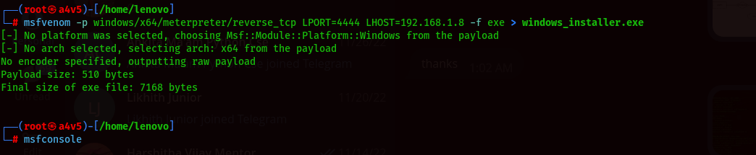

Type ifconfig on another terminal and note down your local wlan0 ip

Address.

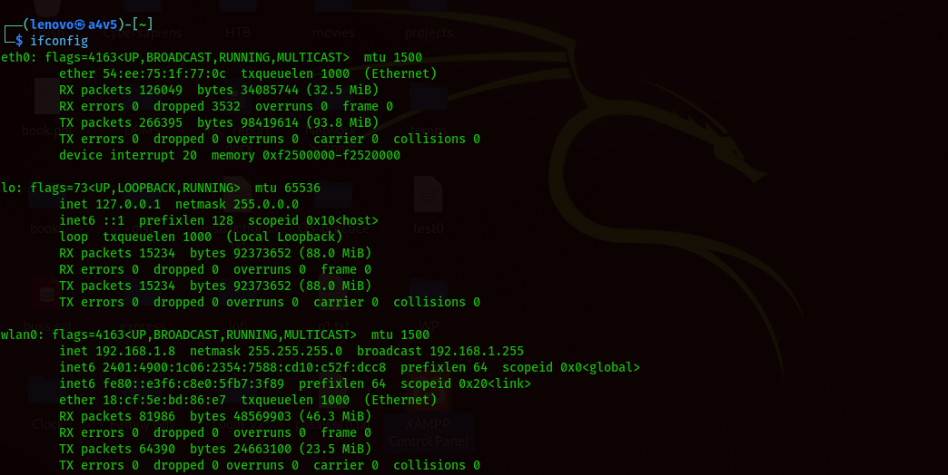

Setup necessary inputs for the listener and in the end type exploit. When the victim clicks on the payload downloaded from the server, you get a session activated and it creates a shell. You now have full access

Over victim’s system.

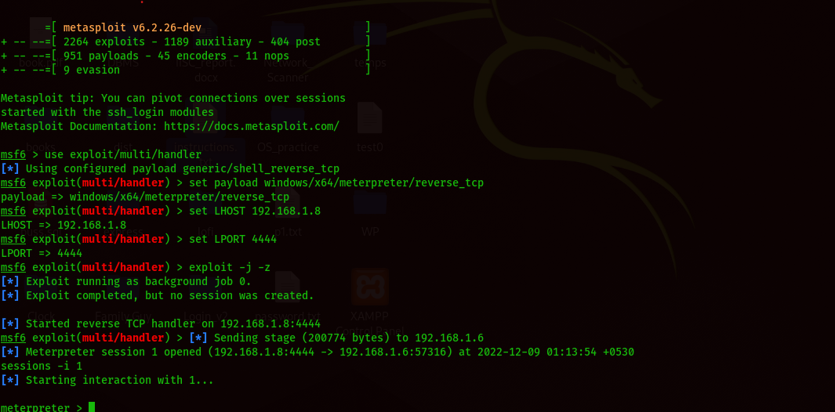

# CONCLUSION AND FUTURE SCOPE

Hence protection of computer systems and information from harm, theft, and unauthorized use is very much necessary. All the systems have their firewalls, inbuilt defenders and Anti-virus software ON to provide protection. In this rapidly advancing world as the technology advances keeping data secure becomes challenging. One should be aware of possible mis-happenings with regard to cyber security and be ready to deal with various attacks and issues that might occur.

The demonstration is limited only with LAN connection. We can improvise it to use ngrok services to make it successfully work across the WAN. It is also possible to use pdfs, png files to be attached with a malware file. Hence it is necessary to spread awareness to people to protect us from such attacks.

# REFERENCES

* <https://www.w3schools.com>
* <https://stackoverflow.com>
* <https://null-byte.wonderhowto.com/>
* <https://getbootstrap.com>
* MDN Web Docs